**MDA’s LOGO**

**TEMPLATE FOR SCIENCE TECHNOLOGY AND INNOVATION MAINSTREAMING ANNUAL WORK PLAN FOR FY 2024-2025**

***STREAM A: - (Applicable to New Entrants and MDAs without Institutional STI Mainstreaming Strategy)***

***(The MDAs shall submit their Work plans before the end of Q1)***

**APPLICABLE TO MDAs IN STREAM A**

| **NAME OF INSTITUTION:** | |  | | | | | | | | |
| --- | --- | --- | --- | --- | --- | --- | --- | --- | --- | --- |
| **S/N** | **PC Indicator(s)** | **ACTIVITY** | **SPECIFIC ACTIVITIES** | **OUTPUT** | **TIME FRAME** | | | | **Budget Allocation** | **Responsibility** |
| **Q1** | **Q2** | **Q3** | **Q4** |
| **APPLICABLE TO MDAs IN STREAM A :**  **PART A-I: PROVISION OF RESEARCH, SCIENCE, TECHNOLOGY AND INNOVATION (RSTI) DATA** | | | | | | | | | | |
|  | **Appoint or Re-appoint Focal Person and champions** | Appoint Focal Person and Champions | e.g. issuance of letter of appointment | * Letter of Appointment |  |  |  |  |  | CEO |
|  | **Attend a training for Focal person and Champions** | Training of Focal Person and champions | e.g., Participate in training programmes organized by NACOSTI | * Certificate * Training reports |  |  |  |  |  | Focal Person |
|  | **Sensitize Staff/ Stakeholders on STI** | Schedule sensitization for Staff/ Stakeholders | e.g., Undertake sensitization to Staff/ Stakeholders | * Attendance Sheet * Sensitization reports |  |  |  |  |  | Focal Person |
|  | **Provide details and submit evidence as requested on RSTI** | 1. SECTION A. Research, Science, Technology and Innovation (RSTI) Human Resources Capacity | * Populate Table 1 on current in post staff & Table 2 on Human Resource Capacity | Populated Table 1 on current in post staff & Table 2 on Human Resource Capacity |  |  |  |  |  |  |
| 1. SECTION B. Research, Science, Technology, and Innovation (RSTI) infrastructure, facilities and equipment | * Populate Table 3 on Research, Science, Technology and Innovation (RSTI) **current working equipment and facilities that are worth Ksh. 500,000 and above.** | Reports 3 on Research, Science, Technology and Innovation (RSTI) equipment and facilities |  |  |  |  |  |  |
| 1. SECTION C. Research, Science, Technology and Innovation (RSTI) expenditure | * Populate Table 4 on Research and Development Expenditure **over the last five (5) years or since the institution was established (whichever is less), segregated for each year.**   *(Note: previously uploaded data will be activated by NACOSTI)* | Data on Research and Development Expenditure |  |  |  |  |  |  |
| 1. SECTION D. Research, Science, Technology and Innovation (RSTI) inputs | * Populate Table 5 on Collaborative Research, Science, Technology and Innovation (RSTI) Programmes or Projects **over the last five (5) years or since the institution was established (whichever is less), segregated for each year.**   *(Note: previously uploaded data will be activated by NACOSTI)* | Report on Collaborative Research, Science, Technology and Innovation (RSTI) Programmes or Projects |  |  |  |  |  |  |
| 1. SECTION E. Research, Science, Technology and Innovation (RSTI) outputs | * Populate the Table 6 on Research, Technology and Innovation Outputs over the last twenty (20) years or since the institution was established (whichever is less) clearly indicating the year of each entry or item. * Attach evidence for all Research, Technology and Innovation Outputs | Data on RSTI outputs |  |  |  |  |  |  |
| 1. SECTION F. Research, Science, Technology and Innovation (RSTI) Dissemination | * Populate Table 7 on Dissemination of Research, Technology, and Innovation products or services.   *(Note: previously uploaded data will be activated by NACOSTI)* | Reports on Dissemination of Research, Technology, and Innovation products or services. |  |  |  |  |  |  |
|  |  | 1. SECTION G.   Institution’s contribution to Kenya’s Global Innovation Index (see Annex 3(c) and URL below)  <https://www.wipo.int/en/web/global-innovation-index/2023/index> | Undertake Self-Assessment on the Institution’s contribution to Kenya’s Global Innovation Index (see Annex 3(c) and URL below)  <https://www.wipo.int/en/web/global-innovation-index/2023/index> | Self-Assessment Report |  |  |  |  |  |  |
|  | **Submit quarterly reports to NACOSTI**  **in the prescribed**  **format (as provided**  **on the NACOSTI**  **website) within 15**  **days after the end of**  **the quarter.** | Timely Submission of Q1 (***By 15th October 2024***), Q2(***By 15th January 2025***), Q3 (***By 15th April 2025***), and Q4 (***By 15th July 2025***) Reports | Timely Submission of reports | Quarterly reports |  |  |  |  |  |  |

| **APPLICABLE TO MDAs IN STREAM A**  **PART A-II:**  **INSTITUTIONAL STI MAINSTREAMING STRATEGY DEVELOPMENT & IMPLEMENTATION (BASED ON STI PRIORITIES)** | | | | | | | | | | | | | |
| --- | --- | --- | --- | --- | --- | --- | --- | --- | --- | --- | --- | --- | --- |
| **S/N** | **PC SUB-INDICATOR(S)** | **ACTIVITY/INITIATIVE** | **SPECIFIC ACTIVITIES** | **OUTPUT** | **TIMEFRAME** | | | | | **BUDGET ALLOCATION** | **RESPONSIBILITY** | | |
| **Q1** | **Q2** | | **Q3** | **Q4** |
| **1.** | **Develop STI Mainstreaming Strategy using the template provided by NACOSTI *(This will be anchored on the guidelines provided in the NACOSTI website*** | Develop STI Mainstreaming Strategy **whose core strategic issues or initiatives are derived from the National Research, Science, Technology and Innovation Priorities (see Annex 1)**  (Details available at:  https://www.nacosti.go.ke/nacosti/Docs/2024/National%20STI%20Priorities.pdf)  **depending on the institution’s mandate and** **functions, and as shall be as guided by NACOSTI.** | STI Mainstreaming Committee to develop a draft STI Mainstreaming Strategy aligned to National Research, Science, Technology and Innovation Priorities (see Annex 1) | * Minutes * Attendance Sheet * Draft STI Mainstreaming Strategy |  |  | |  |  |  |  | | |
| Engage the internal stakeholders to validate the draft STI Mainstreaming Strategy | * Attendance Sheet * Validation report |  |  | |  |  |  |  | | |
| Approval of the STI strategy | * Approved STI Mainstreaming Strategy |  |  | |  |  |  |  | | |
| **2.** | **Implementation of the STI Mainstreaming Strategic Issues**  ***(Implement STI strategic issues identified in their respective Institutional STI Mainstreaming strategy)*** | E.g.  Science, Technology and Innovation (STI) Education, Communication, Talent Development, and Next - generation Workforce | *e.g. (pick at least 3 from below)*   * *Adopt a continuous review and implementation of the education curriculum to respond to the needs of the STI sector* * *Train staff on current and emerging issues on RSTI including STI Communication and Diplomacy* * *Increase RTI personnel (PhDs and Masters level) by x%* * *Enhance gender parity in STI programmes.* * *Provide mechanisms to attract and retain human resource in STI;* * *Develop a mechanism for recognizing and rewarding achievements in RSTI*   *OR*  *Provide financial support to a public institution to undertake the above*  *OR*  *Formally partner with a public institution to undertake the above*  *OR*  *Formally regulate and assure quality as well as relevance in the implementation of activities listed above as the legally mandated Regulatory Authority or Agency (RAA)*  *OR*  *Oversee and ensure implementation of the above listed activities as the parent Ministry/State Department* |  |  |  | |  |  |  |  | | |
| E.g.  R&D Strengthening, R&D Priorities, R&D Financing and R&D Infrastructure  **(see Annex 3(a))** | *e.g. (pick at least 3 from below)*   * *Determine institutional Research Priorities aligned to national development agenda* * *Establish, operationalize, and train a committee for research grant applications* * *Develop a framework for resource mobilization for R&D* * *Establish and fund Research Chair Programmes focused on National STI Priorities* * *Establish and fund Research and/or Innovation Centre of Excellence and/or Science/Technology Park/incubation centre focused on National STI Priorities* * *Publish scientific papers in reputable/globally recognized refereed journals* * *Develop a mechanism for recognizing and rewarding research excellence* * *Determine annual R&D performance based on R&D Indicators specified by NACOSTI in Annex 3(a).*   *OR*  *Provide financial support to a public institution to undertake the above*  *OR*  *Formally partner with a public institution to undertake the above*  *OR*  *Formally regulate and assure quality as well as relevance in the implementation of activities listed above as the legally mandated Regulatory Authority or Agency (RAA)*  *OR*  *Oversee and ensure implementation of the above listed activities as the parent Ministry/State Department* |  |  |  | |  |  |  |  | | |
| E.g.  STI Inclusivity, Diversity, Advocacy, Diplomacy, Governance, legal framework, and Policy Reviews | *e.g. (Pick at least 3 from below)*   * *Participate in, and/or coordinate annual RSTI related conferences, science weeks, congresses, STI Olympiads, STEM mentorship programmes, exhibitions, fairs and expert dialogues.* * *Undertake programmes or activities that enhance gender equality and inclusivity in the STI Sector* * *Undertake training on STI Diplomacy* * *Engage with the County Governments on STI-based innovative county development strategies and programmes* * *Undertake or undertake RSTI policy/legal and governance framework reviews*   *OR*  *Provide financial support to a public institution to undertake the above*  *OR*  *Formally partner with a public institution to undertake the above*  *OR*  *Formally regulate and assure quality as well as relevance in the implementation of activities listed above as the legally mandated Regulatory Authority or Agency (RAA)*  *OR*  *Oversee and ensure implementation of the above listed activities as the parent Ministry/State Department* |  |  |  | |  |  |  |  | | |
| E.g.  Technology Protection, Diffusion, and Commercialization | *e.g. (Pick at least 3 from below)*   * *Align Technology Development activities to National STI Priorities* * *Create awareness on innovation cycle, and the importance of Intellectual Property Rights.* * *Develop and implement institutional Intellectual Property Policy in line with STI Regulations* * *Ensure prompt disclosure of research outputs is made to the relevant office, and a legal framework of royalties put in place* * *Submit applications for Patents, and other IP Rights* * *Strengthen industry-academia linkages within the Quintuple helix framework to encourage commercialization, venture capitalists, and spin-offs* * *Establish technology transfer, and industrial liaison offices.* * *Participate in annual conferences, exhibitions, science weeks, and expert dialogues pertaining STI* * *Undertake investments or partnerships in Manufacturing, Infrastructure development, MSMEs, Start-ups, Technology Parks, and Smart Technologies*   *OR*  *Provide financial support to a public institution to undertake the above*  *OR*  *Formally partner with a public institution to undertake the above*  *OR*  *Formally regulate and assure quality as well as relevance in the implementation of activities listed above as the legally mandated Regulatory Authority or Agency (RAA)*  *OR*  *Oversee and ensure implementation of the above listed activities as the parent Ministry/State Department* |  |  |  | |  |  |  |  | | |
| E.g.  Strategic Multi-Agency, Multisectoral, and International Cooperation and Partnerships in RSTI  ***Note:***  ***The quintuple innovation or collaboration helix framework describes (i)university-(ii)industry-(iii)government-(iv)public-(v)environment interactions within a knowledge economy.***  undefined | *e.g.*   * *Participate or enlist in international conferences, international workshops, national dialogues, and STI networks at national, regional and international levels* * *Participate in formal multi-agency teams and taskforces* * *Establish multidisciplinary, multi-agency, and multi- institutional teams for collaborative research and technology development* * *Establish Quintuple helix partnership frameworks for RSTI* * *Provide financial support to multi-agency, multisectoral, multidisciplinary teams*   *OR*  *Formally regulate and assure quality as well as relevance in the implementation of activities listed above as the legally mandated Regulatory Authority or Agency (RAA)*  *OR*  *Oversee and ensure implementation of the above listed activities as the parent Ministry/State Department* |  |  |  | |  |  |  |  | | |
| Others may include:  Activities to fast track the attainment of Bottom Economic Transformation Agenda as well as enhance national security, viz, activities in:   1. Health Security, and Substance Abuse Mitigation (including Pharmaceuticals/Traditional medicine Production) 2. STI for Food Security, Nutrition, Smart Agriculture, and harnessing of indigenous knowledge and technologies 3. STI for SDGs, Climate Change Mitigation, and Harnessing of the Blue Economy/Aquatic Resources 4. STI for Sustainable Urbanization, County Development, and Resilient Communities 5. Infusion of modern technologies into the operations of an institution to enhance service delivery 6. The Fifth Industrial Revolution, Digital Economy, Data Governance and Emerging/Frontier Technologies 7. STI for National Security, Public safety and Emergency Response |  |  |  |  | |  |  |  |  | | |
| Others (Specify) |  |  |  |  | |  |  |  |  | | |
| **3.** | **Submit quarterly reports to NACOSTI**  **in the prescribed**  **format (as provided**  **on the NACOSTI**  **website) within 15**  **days after the end of**  **the quarter.** | Timely Submission of Q1 (***By 15th October 2024***), Q2(***By 15th January 2025***), Q3 (***By 15th April 2025***), and Q4 (***By 15th July 2025***) Reports | Timely Submission of reports | Quarterly reports |  | |  |  |  |  | |  |

**Annex 1: Science, Technology and Innovation Priorities** [***https://www.nacosti.go.ke/nacosti/Docs/2024/National%20STI%20Priorities.pdf***](https://www.nacosti.go.ke/nacosti/Docs/2024/National%20STI%20Priorities.pdf)

**Annex 2: Research and Innovation Cycle, and Guidelines for Intellectual Property Management Policy**

**Annex 2(b) : Guidelines for Intellectual Property Management Policy**

**(Legal Notice No. 107: STI (Relevance and Quality Assurance in Research) Regulations 2024)**

**Annex 2(a) : Research and Innovation Cycle**

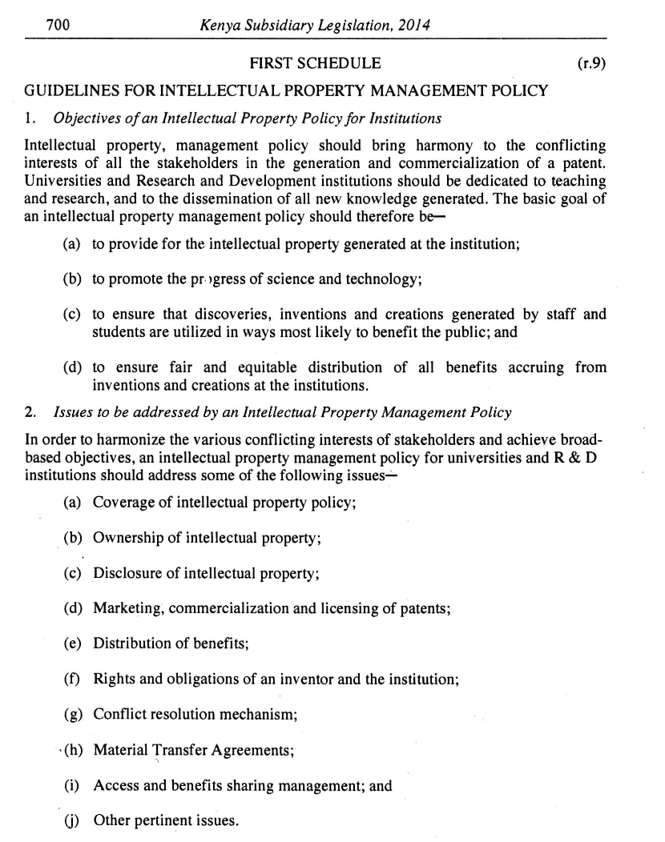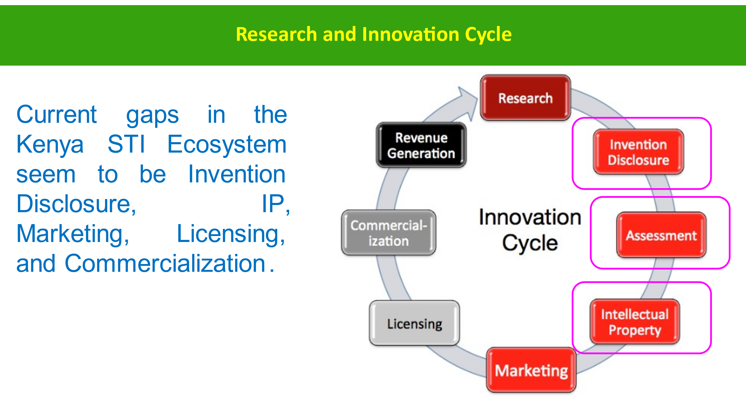

**Annex 3(a): Annual Research and Development Performance Indicators for institutions**

|  |  |  |  |  |
| --- | --- | --- | --- | --- |
|  | **Performance Indicator** | **Current year** | **Prior year** | **Remarks** |
|  | Institutional expenditures on R&D as a percentage of total income (%)  *Also list:  Institutional expenditures on R&D = Kshs -------  Total income = Kshs ---------------- |  |  |  |
|  | Funding for research received from the private sector or donors as a percentage of total income (%)  *Also list:  Funding for research received from the private sector or donors – Kshs ---------- |  |  |  |
|  | No. of R&D staff as a percentage of total no. of staff  *Also list:  Total No. of R&D staff= -----  Total No. of staff= ------- |  |  |  |
|  | No. of staff with PhD as a percentage of total no. of staff  Also list:  Total No. of staff with PhD = ----- |  |  |  |
|  | No. of **ongoing** licensed research |  |  |  |
|  | No. of ongoing licensed research that involve **quintuple helix partnerships or collaborations** |  |  |  |
|  | No. of licensed research **completed** in the year |  |  |  |
|  | No. of licensed research **completed** in the year that involve **quintuple helix partnerships or collaborations** |  |  |  |
|  | No. of licensed research **completed** in the year |  |  |  |
|  | No. of **unlicensed** research |  |  |  |
|  | No. of publications in Scopus indexed journals over the last five years |  |  |  |
|  | No. of patents or plant breeders’ rights **applications during the year** |  |  |  |
|  | No. of patents or plant breeders’ rights **granted over the last twenty (20) years** |  |  |  |
|  | Total amount of **royalties** from R&D Products which have been commercialized or licensed to other entities (Kshs) during the year |  |  |  |

**Annex 3(b): Global STI Indicators/Scorecard**

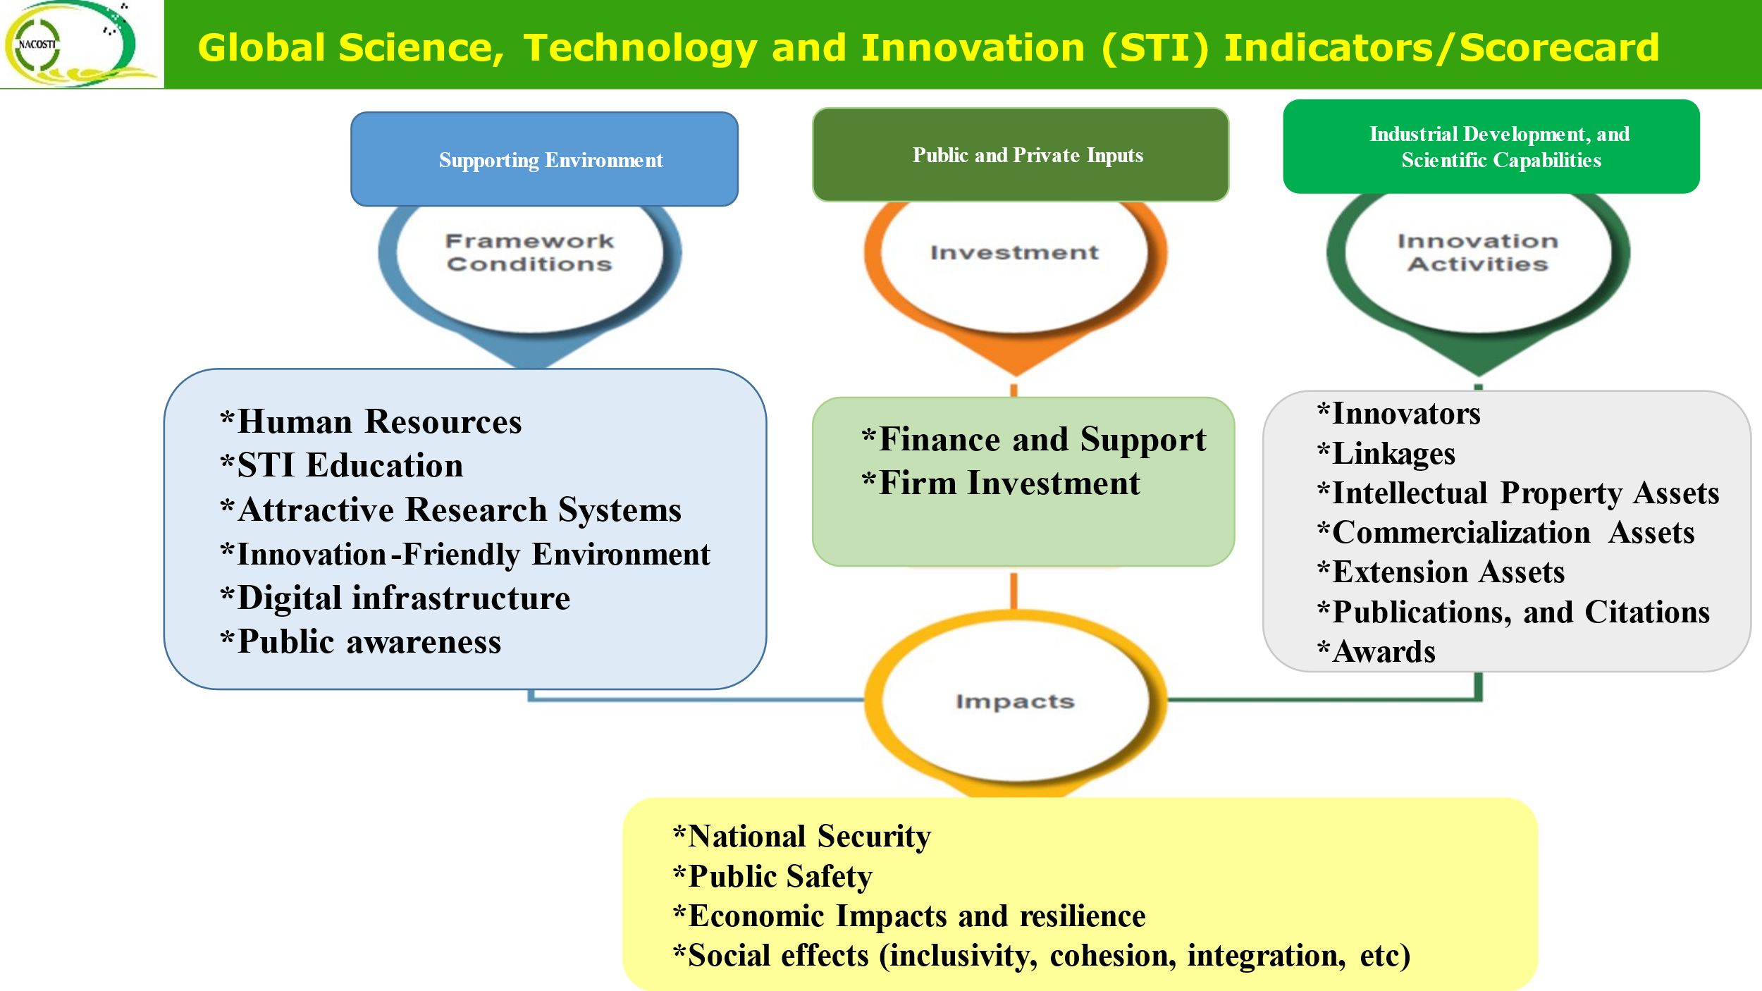

**Annex 3(c): Global Innovation Index (GII) Indicators for 2023**

Simplified Self Evaluation Template on “Institutional Contribution to Kenya’s Global Innovation Index:.

|  |  |  |  |  |  |  |
| --- | --- | --- | --- | --- | --- | --- |
|  | **Performance Indicator** | **Scoring criteria** | | | | **Self Evaluation Score** |
|  |  | **8 to 10** | **6 to 7.9** | **4 to 5.9** | **0 to 3.9** | **Max. 10** |
|  | Institutional expenditures on R&D as a percentage of total income (%) = | 80% and over | 60% to 79% | 40% to 59% | Below 39% |  |
|  | Institutional support for staff development, start-ups, venture capital projects, technology parks, young scientists (Kshs) | **8 million and over** | **6 to 7.9 million** | **4 to 5.9 million** | **0 to 3.9 million** |  |
|  | Funding for research received from the private sector or donors as a percentage of total income (%) | 80% and over | 60% to 79% | 40% to 59% | Below 39% |  |
|  | No. of R&D staff as a percentage of total no. of staff | 80% and over | 60% to 79% | 40% to 59% | Below 39% |  |
|  | No. of publications in Scopus indexed journals over the last five years | 80 and over | 60 to 79 | 40 to 59 | Below 39 |  |
|  | No. of patents or plant breeders’ rights **applications during the year** | 80 and over | 60 to 79 | 40 to 59 | Below 39 |  |
|  | No. of patents or plant breeders’ rights **granted over the last twenty (20) years** | 80 and over | 60 to 79 | 40 to 59 | Below 39 |  |
|  | No. of Trademark **applications during the year** | 80 and over | 60 to 79 | 40 to 59 | Below 39 |  |
|  | No. of Trademarks **granted over the last twenty (20) years** | 80 and over | 60 to 79 | 40 to 59 | Below 39 |  |
|  | No. of ongoing or completed **Collaborative** Programmes or Projects involving the private sector over the last five (years). | 8 and over | 6 to 7 | 4 to 5 | 0 to 3 |  |
|  | Investments in ICT (Kshs) | 80 million and over | 60 to 79 million | 40 to 59 million | Below 39 million |  |
|  | Key policies developed and implemented | IP, Research, Research security, and STI Strategy | IP, Research, and STI Strategy | IP and STI Strategy | STI Strategy |  |
|  | For regulatory agencies: No. of agencies regulated during the year |  |  |  |  |  |
|  |  | **8 to 10** | **6 to 7.9** | **4 to 5.9** | **0 to 3.9** |  |

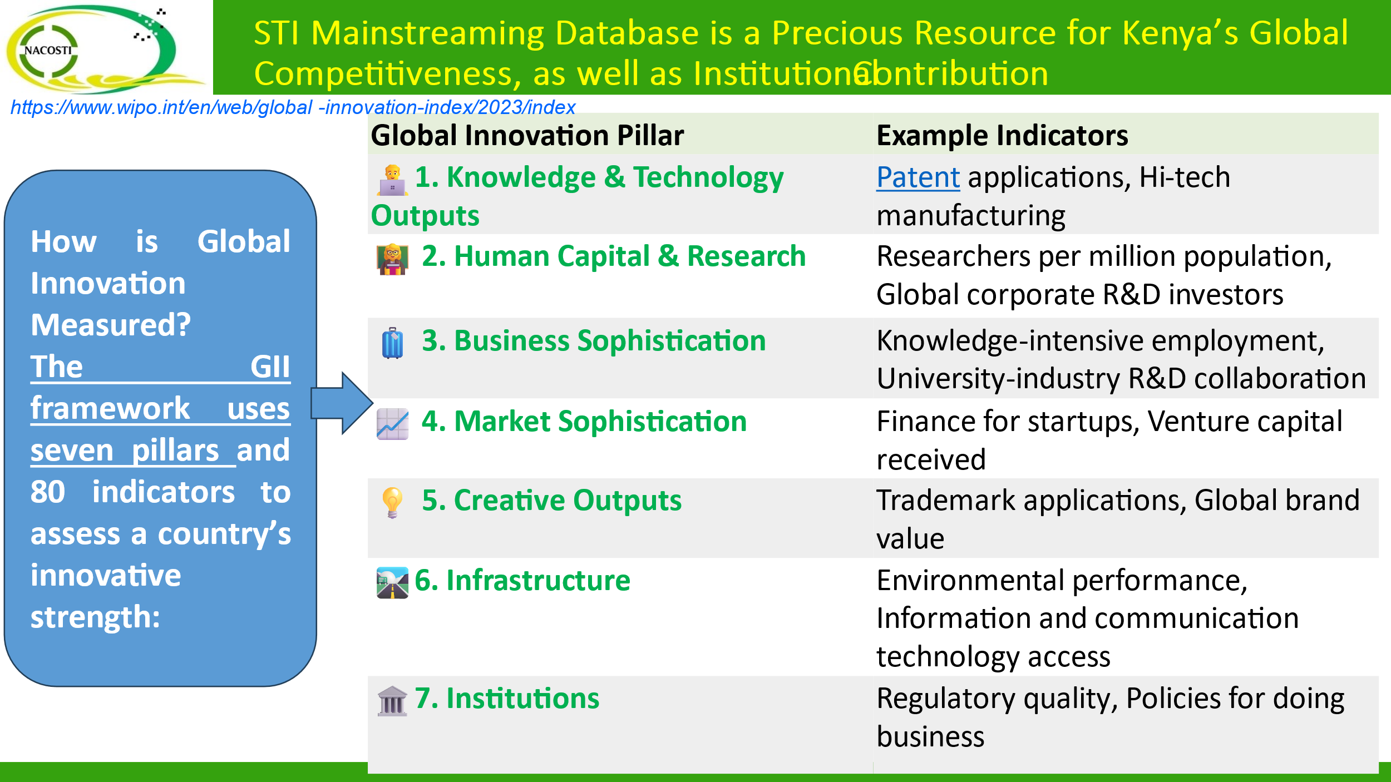

**Annex 4: The Quintuple Helix Innovation or Partnership Model**

The quintuple helix innovation or partnership model represents the interaction between the (i) **academia** (the university or higher education institutions) referred to as the education subsystem,  (ii) **industry** referred to as the economic subsystem, (iii) **government** referred to as the political subsystem, (iv) **civil society/publics** referred to as the public/culture subsystem , and (v) **environment** referred to as the natural environment subsystem, aimed at fostering holistic social-economic development and security in a  knowledge economy and knowledge society.

Each of the subsystems has a unique ingredient that is of societal and scientific relevance to complement the other subsystems i.e., human capital, economic capital, natural capital, social capital, information capital, political and legal capital. The quintuple helix model brings into focus the quality and impact of: innovation systems; international cooperation; forest-based bio-economies; ecosystems and green energy agenda; smart specialization and living labs; climate change, and sustainable development, as well as science, technology and innovation diplomacy.

