**MDA’s LOGO**

**TEMPLATE FOR SCIENCE TECHNOLOGY AND INNOVATION MAINSTREAMING ANNUAL WORK PLAN FOR FY 2024-2025**

***STREAM B: - (Applicable to Institutions with Approved Institutional STI Mainstreaming Strategy)***

***(The MDAs shall submit their Work plans before the end of Q1)***

**APPLICABLE TO MDAs IN STREAM B**

| **NAME OF INSTITUTION:** | |  | | | | | | | | |
| --- | --- | --- | --- | --- | --- | --- | --- | --- | --- | --- |
| **S/N** | **PC Indicator(s)** | **ACTIVITY** | **SPECIFIC ACTIVITIES** | **OUTPUT** | **TIME FRAME** | | | | **Budget Allocation** | **Responsibility** |
| **Q1** | **Q2** | **Q3** | **Q4** |
| **APPLICABLE TO MDAs IN STREAM - B**  **PART B-I : PROVISION OF RESEARCH, SCIENCE, TECHNOLOGY AND INNOVATION (RSTI) DATA** | | | | | | | | | | |
|  | **Appoint or Re-appoint Focal Person and champions** | Appoint Focal Person and Champions | e.g. issuance of letter of appointment | * Letter of Appointment |  |  |  |  |  | CEO |
|  | **Attend a training for Focal person and Champions** | Training of Focal Person and champions | e.g., Participate in training programmes organized by NACOSTI | * Certificate * Training reports |  |  |  |  |  | Focal Person |
|  | **Sensitize Staff/ Stakeholders on STI** | Schedule sensitization for Staff/ Stakeholders | e.g., Undertake sensitization to Staff/ Stakeholders | * Attendance Sheet * Sensitization reports |  |  |  |  |  | Focal Person |
|  | **Provide details and submit evidence as requested on RSTI** | 1. SECTION A. Research, Science, Technology and Innovation (RSTI) Human Resources Capacity | * Populate Table 1 on current in post staff & Table 2 on Human Resource Capacity | Populated Table 1 on current in post staff & Table 2 on Human Resource Capacity |  |  |  |  |  |  |
| 1. SECTION B. Research, Science, Technology, and Innovation (RSTI) infrastructure, facilities and equipment | * Populate Table 3 on Research, Science, Technology and Innovation (RSTI) **current working equipment and facilities that are worth Ksh. 500,000 and above.** | Reports 3 on Research, Science, Technology and Innovation (RSTI) equipment and facilities |  |  |  |  |  |  |
| 1. SECTION C. Research, Science, Technology and Innovation (RSTI) expenditure | * Populate Table 4 on Research and Development Expenditure **over the last five (5) years or since the institution was established (whichever is less), segregated for each year.**   *(Note: previously uploaded data will be activated by NACOSTI)* | Data on Research and Development Expenditure |  |  |  |  |  |  |
| 1. SECTION D. Research, Science, Technology and Innovation (RSTI) inputs | * Populate Table 5 on Collaborative Research, Science, Technology and Innovation (RSTI) Programmes or Projects **over the last five (5) years or since the institution was established (whichever is less), segregated for each year.**   *(Note: previously uploaded data will be activated by NACOSTI)* | Report on Collaborative Research, Science, Technology and Innovation (RSTI) Programmes or Projects |  |  |  |  |  |  |
| 1. SECTION E. Research, Science, Technology and Innovation (RSTI) outputs | * Populate the Table 6 on Research, Technology and Innovation Outputs over the last twenty (20) years or since the institution was established (whichever is less) clearly indicating the year of each entry or item. * Attach evidence for all Research, Technology and Innovation Outputs | Data on RSTI outputs |  |  |  |  |  |  |
| 1. SECTION F. Research, Science, Technology and Innovation (RSTI) Dissemination | * Populate Table 7 on Dissemination of Research, Technology, and Innovation products or services.   *(Note: previously uploaded data will be activated by NACOSTI)* | Reports on Dissemination of Research, Technology, and Innovation products or services. |  |  |  |  |  |  |
|  |  | 1. SECTION G.   Institution’s contribution to Kenya’s Global Innovation Index (see Annex 3(c) and URL below)  <https://www.wipo.int/en/web/global-innovation-index/2023/index> | Undertake Self-Assessment on the Institution’s contribution to Kenya’s Global Innovation Index (see Annex 3(c) and URL below)   * <https://www.wipo.int/en/web/global-innovation-index/2023/index> | Self-Assessment Report |  |  |  |  |  |  |
|  | **Submit quarterly reports to NACOSTI**  **in the prescribed**  **format (as provided**  **on the NACOSTI**  **website) within 15**  **days after the end of**  **the quarter.** | Timely Submission of Q1 (***By 15th October 2024***), Q2(***By 15th January 2025***), Q3 (***By 15th April 2025***), and Q4 (***By 15th July 2025***) Reports | Timely Submission of reports | Quarterly reports |  |  |  |  |  |  |

| **FOR MDAs IN STREAM B:**  **PART B-II: STI MAINSTREAMING STRATEGY IMPLEMENTATION (FOCUSSED ON ESTABLISHMENT OF COLLABORATIONS AND PARTNERSHIPS IN RSTI, AS WELL AS**  **TRANSFER OF TECHNOLOGY(IES) AND/OR INNOVATION(S))** | | | | | | | | | | | |
| --- | --- | --- | --- | --- | --- | --- | --- | --- | --- | --- | --- |
| **S/N** | **PC SUB- INDICATOR(S)** | **ACTIVITY** | **SPECIFIC ACTIVITIES** | **OUTPUT** | **TIMEFRAME** | | | | | **BUDGET ALLOCATION** | **RESPONSIBILITY** |
| **Q1** | **Q2** | **Q3** | | **Q4** |
| **1.** | **Collaborations and Partnerships in RSTI established to implement STI Strategic issues** (30%) | **Choose any of the listed as applicable** |  |  |  |  | |  |  |  |  |
| ***Initiating and implementing Quintuple Helix collaborations and partnerships (see Annex 4), in RSTI to implement STI Strategic issues in the STI Mainstreaming Strategy.***  ***Note:***  ***The quintuple innovation or collaboration helix framework describes (i)university-(ii)industry-(iii)government-(iv)public-(v)environment interactions within a knowledge economy.***  undefined | e.g.   * Conduct a comprehensive stakeholder analysis to identify or update key actors in RSTI sectors relevant to institutional mandate and functions (universities, research institutions, industry/private sector entities, NGOs, communities, government bodies). * Organize at least three (3) roundtable or workshops or trainings or brainstorming joint sessions/forums with (i)academia, (ii)industry/private sector entities, (iii)government representatives, (iv)Civil Society/Publics, and (v) Communities, to discuss STI strategic issues * Facilitate the development and implementation or continuation of collaborative RSTI projects that address specific issues identified in the STI Mainstreaming Strategy * Assess and specify the inputs and outputs from the quintuple helix partnership framework in the form of:  1. Funds (in Kshs) received from the Private Sector or international partners. 2. No. of patent applications made, No. of patents granted, No. of other IP Rights granted e.g. utility models, plant breeders rights, etc, and No. of academic papers published in SCOPUS indexed journals  * Prepare and attach an abstract on institutional quintuple helix partnership programmes (comprising membership, goal(s) or purpose, approach or framework for partnership, outcomes of the partnerships, impact on national development agenda, lessons learnt). | * A detailed map of potential partners * A list of priority areas for collaboration and partnerships * Launch of joint R&D programs * Memorandums of understanding (MoUs) |  |  | |  |  |  | Management, Focal Person, Planning and Partnership Department |
| 2. | Technology(ies) and/or innovation(s) protected through acquisition of IP Rights, commercialized and/or transferred (70%) | **Undertake the activities listed in a standard Research and Innovation cycle (see Annex 2)** | 1. Development and implementation of institutional IP Policy in line with the provisions of STI Regulations ----- and as may be guided by NACOSTI (compulsory for Research Institutions, TVET institutions, and Universities),   Or  Being formally affiliated with an institution which has an existing IP Management Office, and implementing their IP Policy.  2) Develop technologies/innovations/inventions and take measures to ensure invention or technology or innovation Disclosure to IP Management Office  3) Assessment of invention or technology by IP Management Office  4) Application for IP Rights for inventions recommended by IP Management office/researchers, **or** expired IPs recommended for commercialization, **or** peer reviewed papers published out of assessed reports that had no patentable content.  5) Development and implementation of marketing of technology framework  6) Licensing of products/services, **or** development of incubation hubs,  *Set up of innovation hubs, tech parks, or digital platforms where researchers, startups, and industries can collaborate on STI initiatives, or implementation of* commercialization programmes, **or** extension or transfer of protected inventions  7) Reporting on technology uptake and revenue received from inventions or technologies, as well as the state of Research, Science, Technology and Innovation in the institution, **including ensuring that Tables 1 to 7 in Part I are filled accurately and uploaded in the NACOSTI Portal.**  **OR**  Acquisition and deployment of modern technologies relevant to national security, public safety and inclusive sustainable development   * *Identifying emerging technologies* * *Training personnel to understand and implement the new technology* * *Accessing investment and financial support to facilitate the acquisition of technologies* * *Contracting external firms or research institutions to develop technologies* * ***Technology Purchase****: Directly buying developed technologies, either through equipment, software, or intellectual property (IP) rights.* * *Create enabling Factors for Successful Technology deployment or Transfer* * **ensuring that Tables 1 to 7 in Part I are filled accurately and uploaded in the NACOSTI Portal**   (Evidence of technologies acquired, deployment, and a report on impact thereof to service delivery and national development)  **OR**  Financial support to an institution to undertake the above **as well as ensuring that Tables 1 to 7 in Part I are filled accurately and uploaded in the NACOSTI Portal**  *OR*  *Formally regulate and assure quality as well as relevance in the implementation of activities listed above as the legally mandated Regulatory Authority or Agency (RAA)* **as well as ensuring that Tables 1 to 7 in Part I are filled accurately and uploaded in the NACOSTI Portal**  *OR*  *Oversee and ensure implementation of the above listed activities as the parent Ministry/State Department* **as well as ensuring that Tables 1 to 7 in Part I are filled accurately and uploaded in the NACOSTI Portal** | Institutional IP policy  evidence of awareness creation,  no. of submitted reports to IP Management office, No. letters warning researchers who have not made disclosures  evidence of no. of reports assessed promptly  evidence of no. of IP rights application to relevant institution(s), or no. of expired IPs recommended for commercialization, or no. of peer reviewed papers published out of assessed reports that had no patentable content.  evidence of developed framework, training on the same, implementation of the same, achievements  (evidence of:  Licensing **or** developed incubation hubs, ***or*** *Set up of innovation hubs, tech parks, or digital platforms,* ***or*** *implementation of* commercialization programmes, **or** extension or transfer of protected inventions  Financial reports  *Database on technologies acquired, developed, transferred and commercialized*  Evidence of technologies acquired, deployment, and a report on impact thereof to service delivery and national development)  Evidence of support |  |  | |  |  |  | Committee |
| 3. | **Submit quarterly reports to NACOSTI**  **in the prescribed**  **format (as provided**  **on the NACOSTI**  **website) within 15**  **days after the end of**  **the quarter.** | * Timely Submission of Q1 (***By 15th October 2024***), Q2(***By 15th January 2025***), Q3 (***By 15th April 2025***), and Q4 (***By 15th July 2025***) Reports | Timely Submission of reports | Quarterly reports |  |  | |  |  |  |  |

**Annex 1: Science, Technology and Innovation Priorities** [***https://www.nacosti.go.ke/nacosti/Docs/2024/National%20STI%20Priorities.pdf***](https://www.nacosti.go.ke/nacosti/Docs/2024/National%20STI%20Priorities.pdf)

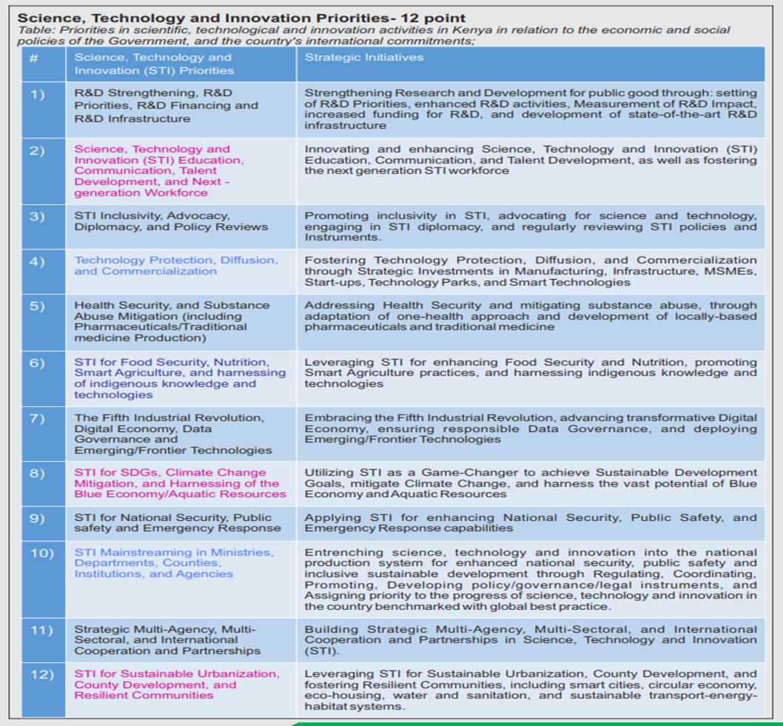

**Annex 2: Research and Innovation Cycle, and Guidelines for Intellectual Property Management Policy**

**Annex 2(b) : Guidelines for Intellectual Property Management Policy**

**(Legal Notice No. 107: STI (Relevance and Quality Assurance in Research) Regulations 2024)**

**Annex 2(a) : Research and Innovation Cycle**

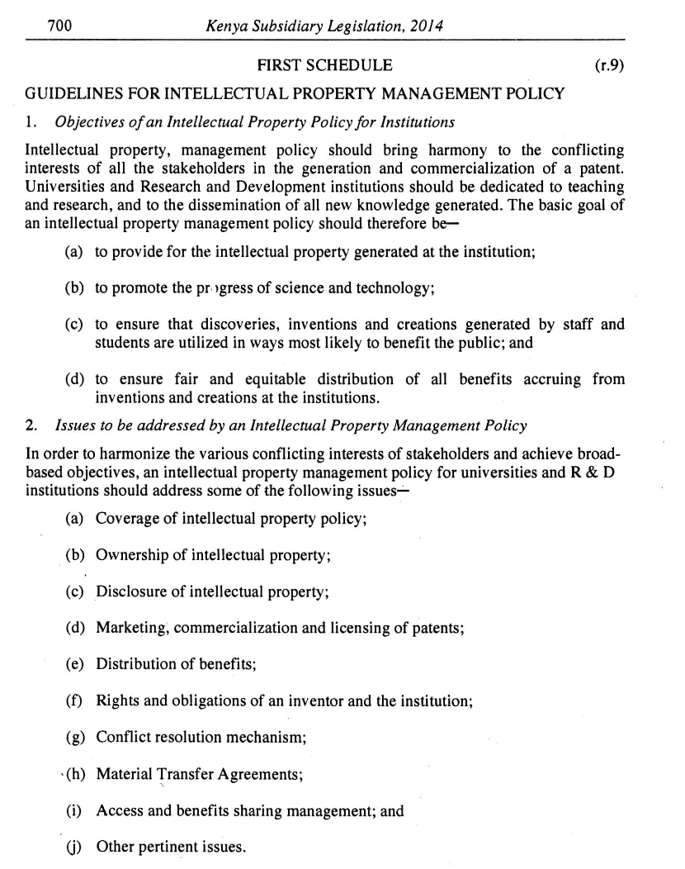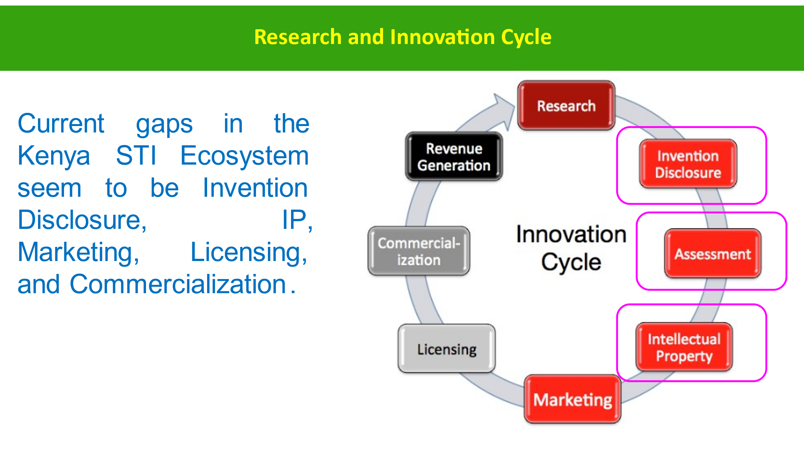

**Annex 3(a): Annual Research and Development Performance Indicators for institutions**

|  |  |  |  |  |
| --- | --- | --- | --- | --- |
|  | **Performance Indicator** | **Current year** | **Prior year** | **Remarks** |
|  | Institutional expenditures on R&D as a percentage of total income (%)  *Also list:  Institutional expenditures on R&D = Kshs -------  Total income = Kshs ---------------- |  |  |  |
|  | Funding for research received from the private sector or donors as a percentage of total income (%)  *Also list:  Funding for research received from the private sector or donors – Kshs ---------- |  |  |  |
|  | No. of R&D staff as a percentage of total no. of staff  *Also list:  Total No. of R&D staff= -----  Total No. of staff= ------- |  |  |  |
|  | No. of staff with PhD as a percentage of total no. of staff  Also list:  Total No. of staff with PhD = ----- |  |  |  |
|  | No. of **ongoing** licensed research |  |  |  |
|  | No. of ongoing licensed research that involve **quintuple helix partnerships or collaborations** |  |  |  |
|  | No. of licensed research **completed** in the year |  |  |  |
|  | No. of licensed research **completed** in the year that involve **quintuple helix partnerships or collaborations** |  |  |  |
|  | No. of licensed research **completed** in the year |  |  |  |
|  | No. of **unlicensed** research |  |  |  |
|  | No. of publications in Scopus indexed journals over the last five years |  |  |  |
|  | No. of patents or plant breeders’ rights **applications during the year** |  |  |  |
|  | No. of patents or plant breeders’ rights **granted over the last twenty (20) years** |  |  |  |
|  | Total amount of **royalties** from R&D Products which have been commercialized or licensed to other entities (Kshs) during the year |  |  |  |

**Annex 3(b): Global STI Indicators/Scorecard**

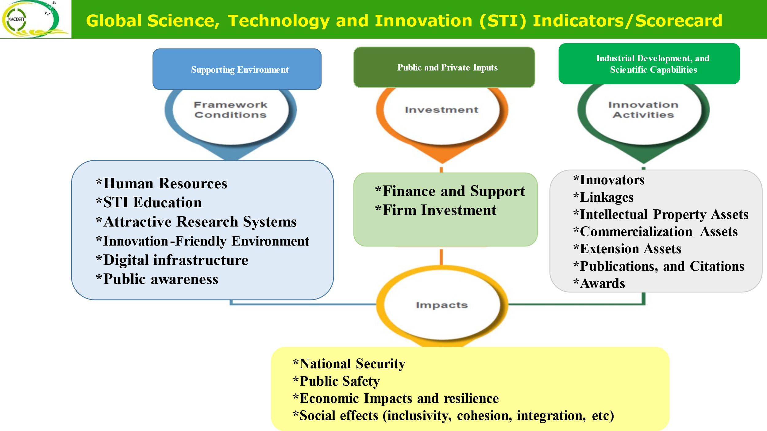

**Annex 3(c): Global Innovation Index (GII) Indicators for 2023**

Simplified Self Evaluation Template on “Institutional Contribution to Kenya’s Global Innovation Index:.

|  |  |  |  |  |  |  |
| --- | --- | --- | --- | --- | --- | --- |
|  | **Performance Indicator** | **Scoring criteria** | | | | **Self Evaluation Score** |
|  |  | **8 to 10** | **6 to 7.9** | **4 to 5.9** | **0 to 3.9** | **Max. 10** |
|  | Institutional expenditures on R&D as a percentage of total income (%) = | 80% and over | 60% to 79% | 40% to 59% | Below 39% |  |
|  | Institutional support for staff development, start-ups, venture capital projects, technology parks, young scientists (Kshs) | **8 million and over** | **6 to 7.9 million** | **4 to 5.9 million** | **0 to 3.9 million** |  |
|  | Funding for research received from the private sector or donors as a percentage of total income (%) | 80% and over | 60% to 79% | 40% to 59% | Below 39% |  |
|  | No. of R&D staff as a percentage of total no. of staff | 80% and over | 60% to 79% | 40% to 59% | Below 39% |  |
|  | No. of publications in Scopus indexed journals over the last five years | 80 and over | 60 to 79 | 40 to 59 | Below 39 |  |
|  | No. of patents or plant breeders’ rights **applications during the year** | 80 and over | 60 to 79 | 40 to 59 | Below 39 |  |
|  | No. of patents or plant breeders’ rights **granted over the last twenty (20) years** | 80 and over | 60 to 79 | 40 to 59 | Below 39 |  |
|  | No. of Trademark **applications during the year** | 80 and over | 60 to 79 | 40 to 59 | Below 39 |  |
|  | No. of Trademarks **granted over the last twenty (20) years** | 80 and over | 60 to 79 | 40 to 59 | Below 39 |  |
|  | No. of ongoing or completed **Collaborative** Programmes or Projects involving the private sector over the last five (years). | 8 and over | 6 to 7 | 4 to 5 | 0 to 3 |  |
|  | Investments in ICT (Kshs) | 80 million and over | 60 to 79 million | 40 to 59 million | Below 39 million |  |
|  | Key policies developed and implemented | IP, Research, Research security, and STI Strategy | IP, Research, and STI Strategy | IP and STI Strategy | STI Strategy |  |
|  | For regulatory agencies: No. of agencies regulated during the year |  |  |  |  |  |
|  |  | **8 to 10** | **6 to 7.9** | **4 to 5.9** | **0 to 3.9** |  |

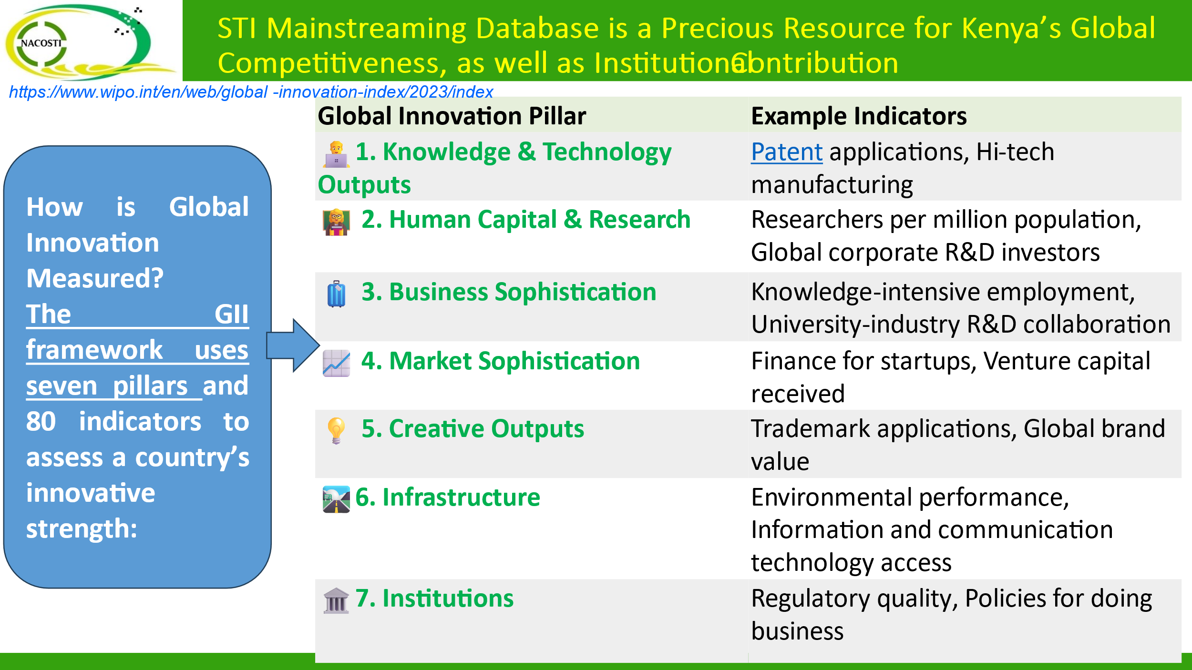

**Annex 4: The Quintuple Helix Innovation or Partnership Model**

The quintuple helix innovation or partnership model represents the interaction between the (i) **academia** (the university or higher education institutions) referred to as the education subsystem,  (ii) **industry** referred to as the economic subsystem, (iii) **government** referred to as the political subsystem, (iv) **civil society/publics** referred to as the public/culture subsystem , and (v) **environment** referred to as the natural environment subsystem, aimed at fostering holistic social-economic development and security in a  knowledge economy and knowledge society.

Each of the subsystems has a unique ingredient that is of societal and scientific relevance to complement the other subsystems i.e., human capital, economic capital, natural capital, social capital, information capital, political and legal capital. The quintuple helix model brings into focus the quality and impact of: innovation systems; international cooperation; forest-based bio-economies; ecosystems and green energy agenda; smart specialization and living labs; climate change, and sustainable development, as well as science, technology and innovation diplomacy.

